Glow Shine Academy Secondary School

**Khairahani-8, Parsa, Chitwan**

**First Terminal Examination- 2082**

**Subject: Art**

**Class: One F.M.:25**

**Name: Roll n****o.:**

**Q.N.1) Colour the picture. [10]**

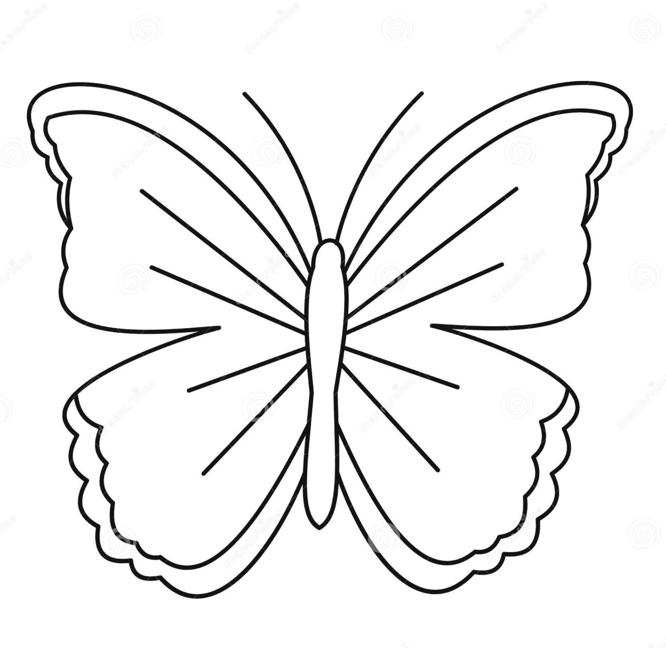

**2. Draw a picture of a cake and colour it. [15]**